## Higher National Diploma in Information Technology

**Object Oriented Programming**

**Lab Sheet 07 - Revision**

1. Using a single *System.out.print* statement create following output(Hint: use escape sequence characters)

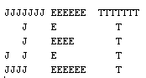

1. Write an application to display your first pay as a Java programmer. Use “FirstPay” as the class name. Define *integer* variables that hold your hourly rate of pay, and number of hours worked. Also declare a constant to hold the tax rate of 50%. (This needs to be defined as a *double*. How do you store 50% as a decimal?).

Now do the calculations so you can display the variables (*doubles*) for the amount of tax payable and your net pay (ie your pay after tax has been deducted).

Display exactly as below including the amounts after the dollar signs:

Gross pay ….. $

Tax deducted $

Net pay …….. $

1. Write an application that converts a specified number of seconds to hours:minutes:seconds.

Create an *integer* variable named time and take input from the user which is a number of seconds. Now convert this into the outputs (*integers*) using both division and the remainder operator ie dividing time by the number of seconds in an hour gives hours. Doing the same operation but using the remainder operator (%) gives the seconds remaining.

Use exactly the same format as shown below:

4220 seconds = 1:10:20

75 seconds = 0:1:15

1. Write a program that produces the following pattern, by using the

statement System.out.print("*"); only once. Try it using nested *for* loops (easiest), then using nested *while* loops for comparison. For the *while* you will see you need to explicitly reset the counting variable in the inner loop.

*****

*****

*****

*****

*****

1. You are to write an application that

* Creates an array for 5 integers
* Loops 5 times asking a user to enter an integer and storing it in the array
* Read through the array and save the highest integer in a variable called max and the lowest in a variable called min
* Display max and min

1. You are to write a program in which the user enters a defined number of numbers between 1 and 100 and stores them in an array. After all the numbers are entered the program calculated and displays the square and cube of each number

The user is prompted for how many numbers are to be entered. The valid number is used to create an empty array of that size.

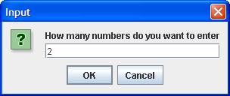

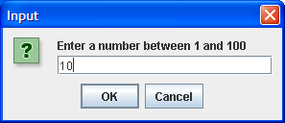

Continue prompting the user to enter numbers until the array has been filled ie in this case 2 numbers between 1 and 100 have been entered.

Write another *for* loop (same as the previous one) to process each number in the array ie

* + get the first number from the array
  + square it and cube it and display the results to 2 decimal places

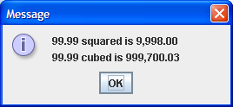

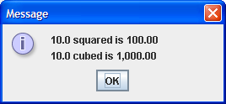

1. You were asked to implement a program which will run on a PIC microcontroller. The basic operation of the program will be as follow.

* First the user will prompt to enter the number of elements that he will enter.
* Then the program will record all the numbers which user enters.
* At the end it will display all the elements as well as the Minimum, Maximum and the Average of the User Entered values.

1. As an software Engineer, you were assigned to develop a program to convert a positive integer to another base.

* Basically the program will prompt for the user for a Number which he/she need to convert the base.
* Then it will prompt for the base.
* After the inputs the program should display the converted number in the required base.

The program should execute as below.

**Number to be converted? 10**

**Base? 2**

**Converted number = 1010**

**Number to be converted? 128362**

**Base? 16**

**Converted number = 1F56A**

1. Write and test a method that returns the maximum of 3 integers. You can try

* hard coding the integers in the program
* have the user enter them
* generate them randomly

The main method should pass the 3 integers to the method called *maxOfThree* with the header:

public static int maxOfThree(int int1, int int2, int int3)

### You are to design and develop a very simple class named *Adder*. This class has two instance variables representing two numbers (doubles) that are added together.

### It should have a constructor that accepts the two numbers as parameters and assigns them to the instance variables.

* It should have an addNumbers method that adds the two numbers together and displays the sum.

Write a driver program to test the class. Its main method should

* prompt the user to enter 2 numbers
* create an object of the Adder class (passing the numbers to the constructor)
* call the addNumbers method